**Project Proposal: BlackBoard**

**Team 3**

* Shefali Kahar
* Sree Kiran Kanchanapally
* Robert Maldonado
* Siddharth Mogulla
* Teja Moka
* Faisal Nahian
* Chikezie Nwakudu

**Table of Contents**

Draft of UML diagram(s) of the BlackBoard system 3

Proposed modules of the system in detail 4

The proposed modules of the system in detail 5

My Institution tab modules 7

Course module pages 7

The What's New and To Do modules 7

Notification settings and actions 8

Add and remove modules 8

Manage module content 9

Minimize a module 10

Open a module in a new window 10

Customize module layout 10

Drag-and-drop function 10

Keyboard accessible reordering 10

Personalize the page 10

Create, edit, or delete a course task 11

View tasks 12

By default, tasks are listed from highest priority to lowest-not by date. To view tasks listed by due date, select the Due Date heading. Use the status columns to view how many students have reported their progress or completed a task. 12

View task progress 12

Add a tasks link to the course menu 12

The Original Course View 13

Course menu 14

Create a link on the course menu 14

Course menu components 15

Reorder and manage course menu links You can organize and rename the course menu links. 15

Control Panel 16

Paging options 16

**1. Draft of UML diagram(s) of the BlackBoard system.**

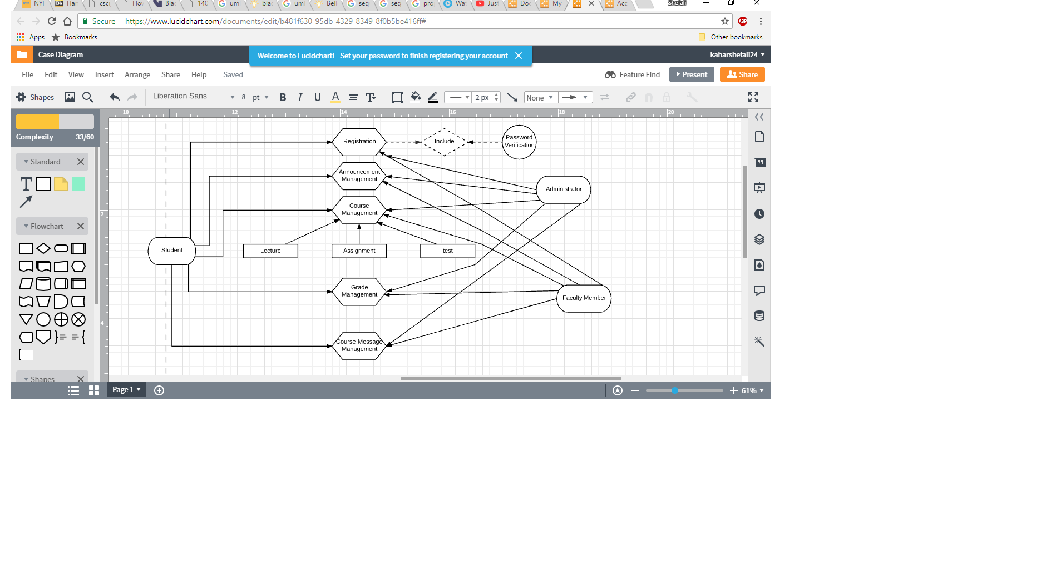

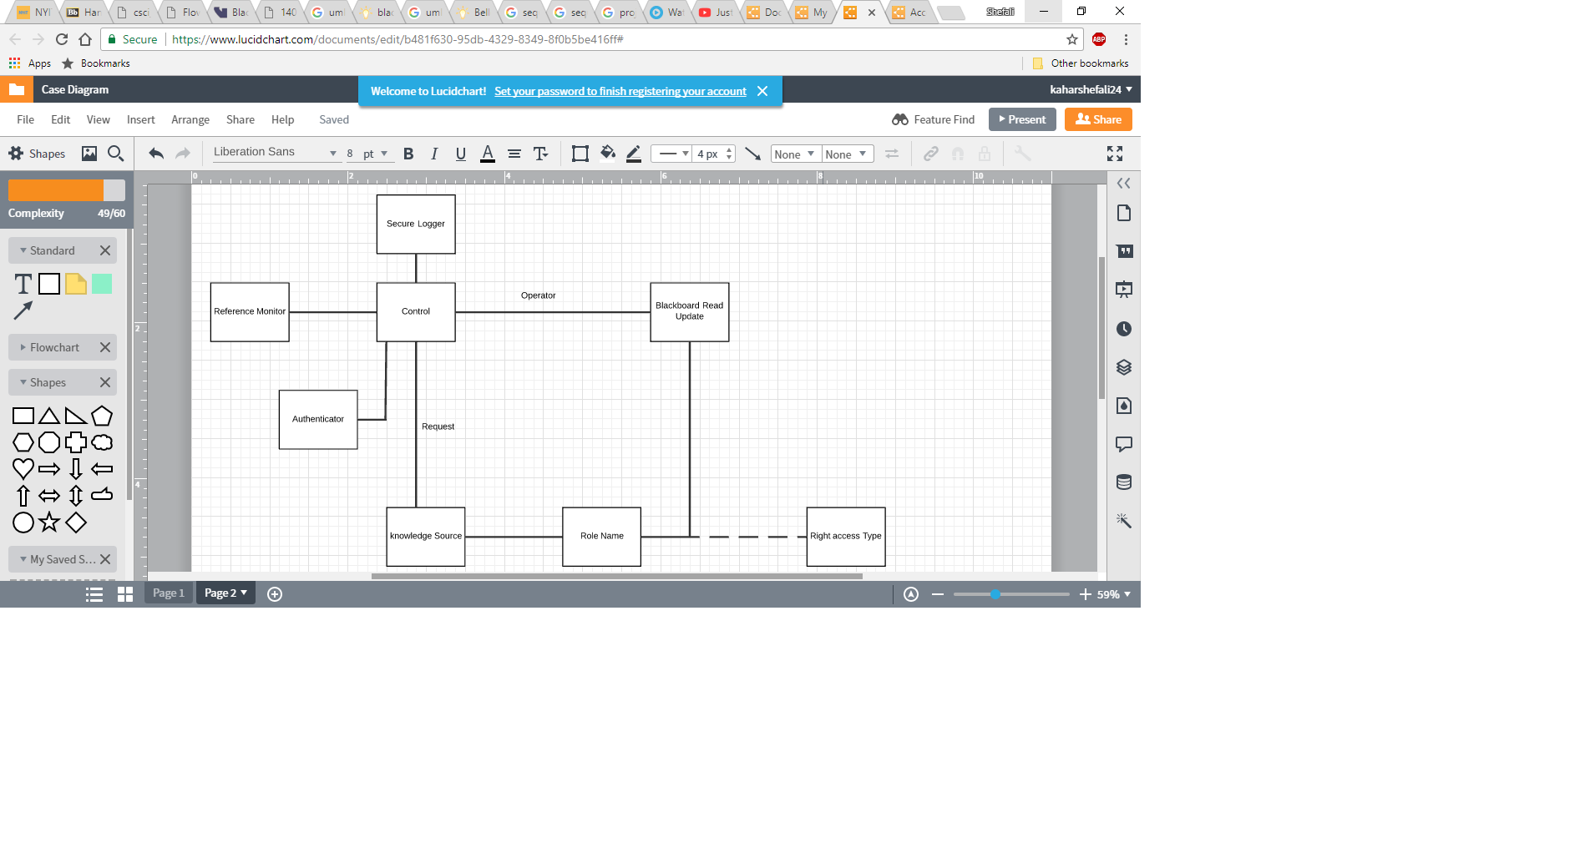

**2. Explain the proposed modules of the system in detail.**

Modules are an organized collection of content presented together that contain data regarding the courses and can be accessed using the regular tools. Instructors will assign a sub module to each module which will have a structured path for every student. Modules can show up on the *My Institution* tab or on course module pages you add to courses, for example, the *Home Page*. The Black Board application may include the following modules:

**1) Courses:** This provides the courses and subjects registered by the student within that semester. The coursework is accessible to both the students and professors for the respected coursework. The coursework includes sub-modules like Assignments, Quizzes and Class Notes.

**a) Assignments:** The sub-module includes the submission of assignments and reports the students if they have submitted in-time or if they were late.

**b) Quizzes:** This includes the quizzes posted by the professor and are open to all the students.

**c) Notes:** This contains the notes or slides, which are posted by the professor, and this is accessed by the students until the end of the coursework.

**2) Announcements:** This module is usually used by the professor to depict his/her views regarding the coursework, or if there are any cancellations of the class.

**3) Tasks:** Tasks are usually assigned by the professor to the students. They need to be completed on time.

**4) Help:** This section includes the related videos and class notes for all the classes. Students are addressed to post their questions or ideas here, so they could either learn from the professors or from their peers.

**5) Discussion Board:** This thread is used to post questions and learn within a team. Given a project or a presentation, teams could discuss in this particular field.

**6) Grades:** This section is used to post grades, which are given by the professor to the students of their respected courses.

**7) Calendars:** The calendar module is used as reminder for assignments or tasks per the due dates.

**3. All functions, tasks you might be implementing.**

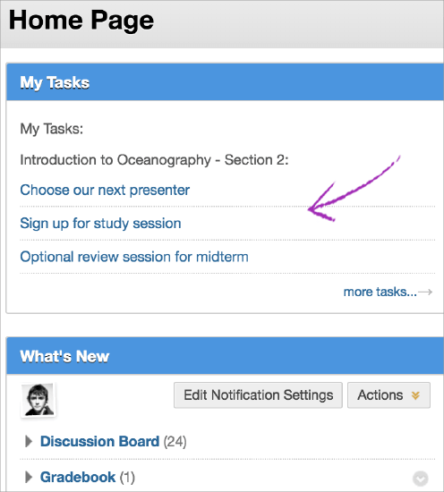**My Tasks:** You can use the tasks tool to organize projects and activities, define task priority, and track students' task status. As an instructor, you add tasks to your course. You can allow students to manage their tasks from the *My Tasks*module or a tool link in your course. You can create tasks and post them to the course Tasks page. Each student can post personal tasks to their own task pages. Task information is arranged in columns that display the priority, task name, status, and due date. Tasks are also available as a course group tool for tasks that are specific to a smaller group within your course.

**Modules**: Modules contain information about what's happening in your courses, and you may be able to access commonly used tools. Examples of modules include *My Announcements, What's New, and Calendar*. You may be allowed to minimize or remove modules, but your institution can require some modules to appear. You may also be allowed to edit the settings for some modules. Modules can appear on the My Institution tab or on course module pages you add to courses, such as the Home Page. The system generates the information in each module. You can't add your own content to module pages.

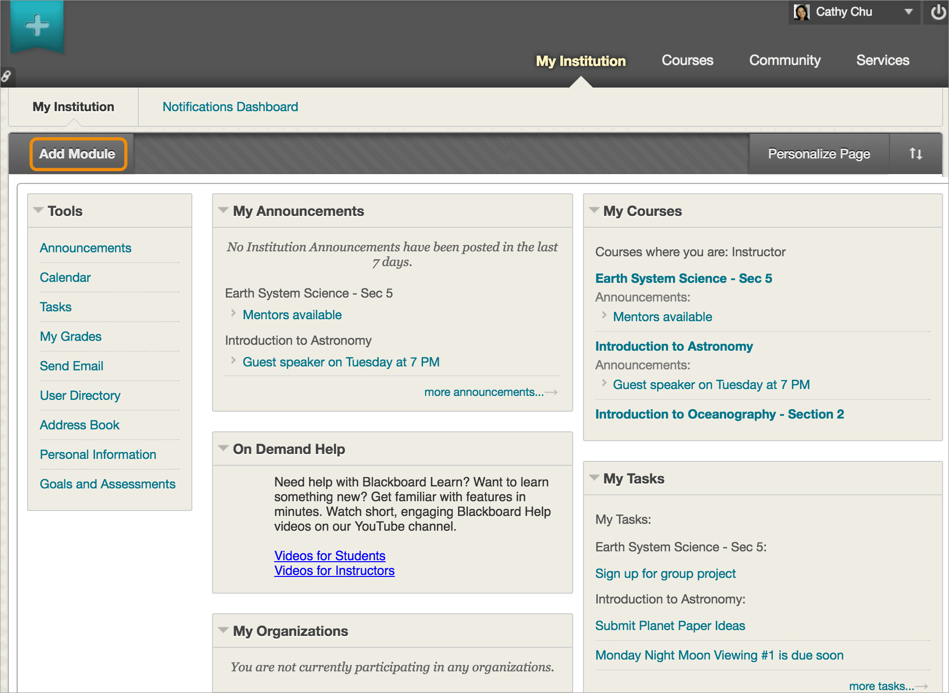**My Institution tab modules:** Modules on the *My Institution* tab collect information from all your courses to give you a total picture of news and activity for your courses.

**Course module pages:** By default, your original course includes a *Home Page* on the course menu. The *Home Page* is a course module page. You can rename or delete this page, and create other course module pages. You also choose which modules appear. Course module pages contain details about new content and due dates for the course you're in.

**What's New module:** The What's New module reports on additions and changes to course content. The module displays the number of new items for each content type and provides links to them in your courses. The module shows items within the last seven days.

These content types are reported in the module:

* Tests and surveys
* Assignments
* Blogs
* Content
* Discussion posts
* Course messages

The What's New module reports changes once a day. You can see what has changed the first time you log in for the day. Changes made after you log in don't appear in the module until the next day unless you select Refresh in the Actions menu.

**To Do module:** The To Do module provides a chronological listing of upcoming due dates. This module is divided into *What's Past Due* and *What's Due*.

***The To Do module isn't the same as the tasks tool.***

Two other modules you might add are the *Alerts* and *Needs Attention* modules. These modules are for your use only and **contain no information for students**.

**Notification settings and actions:** You can edit your notification settings to control which events you're notified about and how the notifications are delivered. Some modules contain an Actions menu with options to expand, collapse, or dismiss the notifications in that module.

Add and remove modules

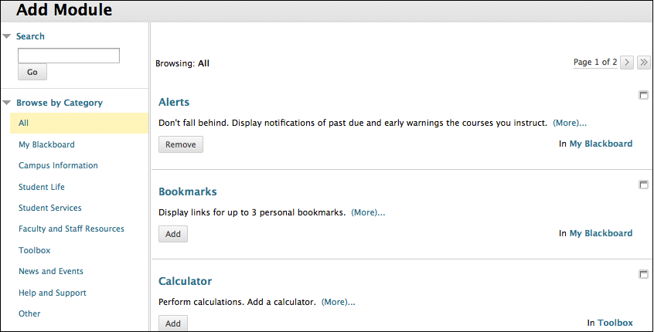You may be allowed to add modules to the *My Institution* tab or another tab that contains modules.

1. Select Add Module.
2. On the Add Module page, select the modules you want to appear on the tab. You can search by keyword or browse by category to find modules. Your institution can disable options.
3. Select Add to place the module on the tab.

To remove a module, select the Close icon located at the top of each module. In the pop-up window, select OK. When you close a module, the module isn't permanently deleted. You can restore closed modules with the Add Module function. Modules that don't have a Close icon are required to appear.

**Manage module content**

To edit information, select the Manage icon located at the top of each module.

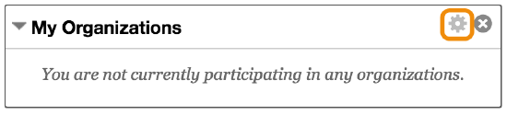Minimize a module

To minimize a module, select the Collapse icon located at the top of each module. To maximize a module, select the Expand icon located at the top of each module.

Open a module in a new window

To open a module in a separate window, select the Open in a new window icon located at the top of each module. If the icon doesn't appear, the option isn't available for that module.

Customize module layout

Use the drag-and-drop function or the keyboard accessible reordering tool to reorder the modules.

Drag-and-drop function

Press and drag the header of a module to move it to a new location. The module is surrounded by a dashed line as you move it. Release the module to place it in its new location.

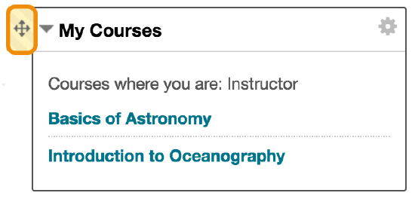

Keyboard accessible reordering

You can use an accessible tool to reorder items.

Select one of the modules. Use the Move Up and Move Down icons to move the module to a new position in a column list. Use the Move Left and Move Right icons to move a module between columns.

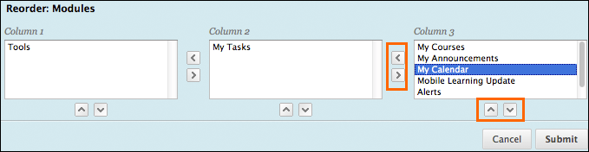Personalize the page

You may be allowed to personalize a tab that contains modules. Select Personalize Page. On the Personalize page, select a color scheme from the Color Palette Library.

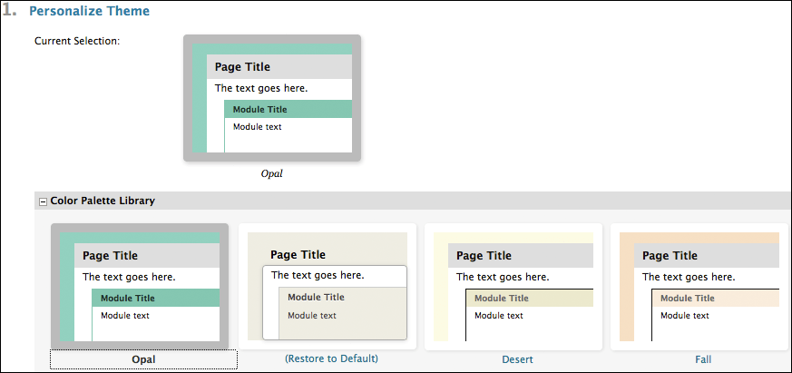

Create, edit, or delete a course task

1. On the course menu, select Tools. On the Tools page, select Tasks.

-OR-

On the Control Panel, expand the Course Tools section and select Tasks.

1. On the Tasks page, select Create Course Task.
2. On the Create Course Task page, type a name, description, and due date. You can use the functions in the editor to format the text and upload files, images, and multimedia.
3. Assign a priority of Low, Normal, or High.
4. Select Submit.
5. The task appears on the Tasks page. Access the task's menu to edit or delete the task.

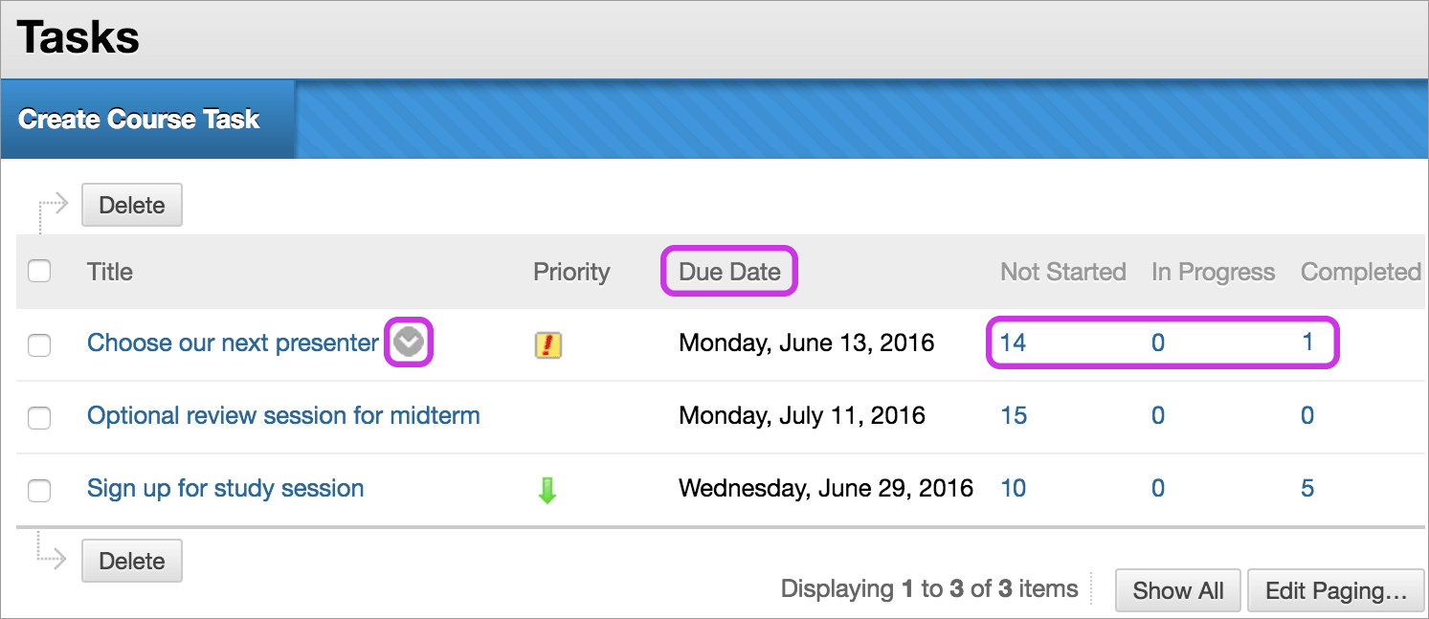**View tasks:** By default, tasks are listed from highest priority to lowest-not by date. To view tasks listed by due date, select the Due Date heading. Use the status columns to view how many students have reported their progress or completed a task.

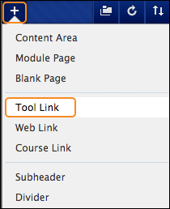**View task progress:** Select a task title to access the View Task page. The View Task page displays all students' progress for that task. Add a tasks link to the course menu. You can add a link to the course menu for instant access to the tasks tool.

You can also customize the name of the link:

1. Change Edit Mode to ON and select the Add Menu Item icon above the course menu to access the menu.
2. Select Tool Link and type a name.
3. From the Type menu, select Tasks.
4. Select the Available to Users check box if you're ready for students to see it.
5. Select Submit.

The new tool link appears last in the course menu list. Press and drag the arrows icon to move the link into a new position. Access the link's menu to rename, delete, or hide the link from students.

**The Original Course View:** In the Original Course View, you can easily navigate, provide content, edit items, and change options that affect how users interact with the interface.

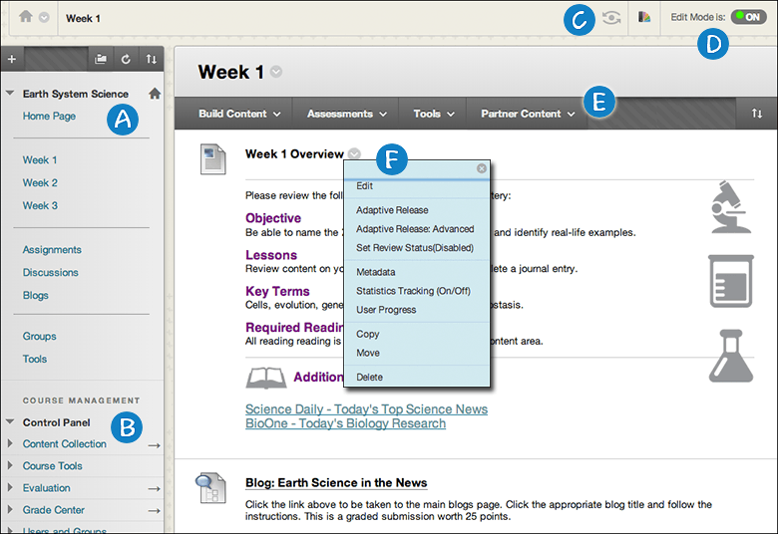

1. **Course menu**: Users' access point for all course content.
2. **Control Panel**: The area after the course menu is your access point for course management functions, such as course style, course tools, and users. Students don't see the Control Panel.
3. **Student preview**: You can review course content and validate course behaviors from a student's perspective. You're logged in with a student account—the preview user account—and enrolled in the current course.
4. **Edit Mode**: When Edit Mode is ON, all the instructor functions appear, such as Build Content or the appearance of menus. When Edit Mode is OFF, all instructor functions are hidden. The Edit Mode function appears to users with a role of instructor, teaching assistant, course builder, and administrator.
5. **Functions**: In one or more rows above the content, access page-level functions such as Build Content, Search, Delete, and Upload. The functions change based on where you are in your course.
6. **Menus**: An Options Menu icon appears for components with menus, such as content items, course menu links, or Grade Center columns. The options in the menu vary based on the component.

**Course menu:** The course menu appears on the left side of your course window and is the cornerstone for the organization and navigation of your course. The course menu appears in a list view, which displays only the top level of course materials. You create links on the course menu to present tools and materials to users. You can customize its appearance and order the links.You can also choose buttons or text for your links.

Select the Display Course Menu in New Window icon to view the course materials as a directory tree in a new window. Users can expand the view to show the hierarchy of course navigation.

*Your institution can restrict options to maintain a consistent style for all courses.*

**Create a link on the course menu**

Create an uncluttered course menu to maintain efficient navigation for your users, and try to limit the number of links included in the course menu. Use content areas to hold related items and give your course organization and structure.

1. Select the Add Menu Item icon above the course menu to access the menu.
2. Select the type of content to create and type a name. Complete any other required text boxes, such as URL for Web Link.
3. Select the Available to Users check box if you're ready for students to see it. You can create content ahead of time, hide the link, and then show the link at the appropriate time.
4. Select Submit. A link to the new content appears on the course menu.

**Course menu components**

This table lists the types of content and tools you can add to the course menu. You can also include sub-headers and divider lines to help visually organize the links for your students.

Reorder and manage course menu links. You can organize and rename the course menu links.

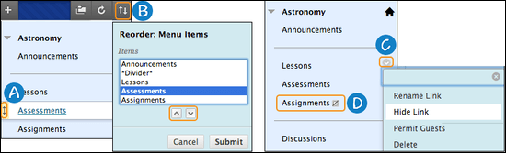

1. Use the drag-and-drop function to reorder course menu links.
2. Or, use the keyboard accessible reordering tool to reorder the links.
3. Access a link's menu and select Rename to change its title. Select Hide Link to make it unavailable to students. Select Show Link to make it available to students. If you Delete a content area, all content items within it are also permanently deleted. This action is final.
4. When Edit Mode is ON, an unavailable link title appears with the This link is hidden from students’ icon. Students don't see the link on the course menu.

**Control Panel**

The Control Panel appears below the course menu and provides access to all course administration. The table describes each section.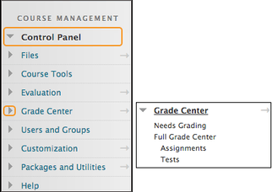 Use the arrows next to each link to expand or collapse the area. The Control Panel is only available if you have one of these course roles: instructor, teaching assistant, grader, course builder, or administrator.

**Paging options**

You can edit the paging options to specify how many items appear on a page. For example, you can determine how many forums appear on the main discussion board page or how many items appear on the Needs Grading page.

The default is 25 items per page and the maximum number of items is 1,000 per page. Show All displays all items and causes the other controls to disappear. For performance, the items per page shouldn't be greatly expanded.

Use these steps to edit the paging options:

1. Select Edit Paging.
2. Type a number in the Items per page box. If the number is greater than the total number of items, then all items appear. If the number is less than one, then one item appears.
3. Select OK.